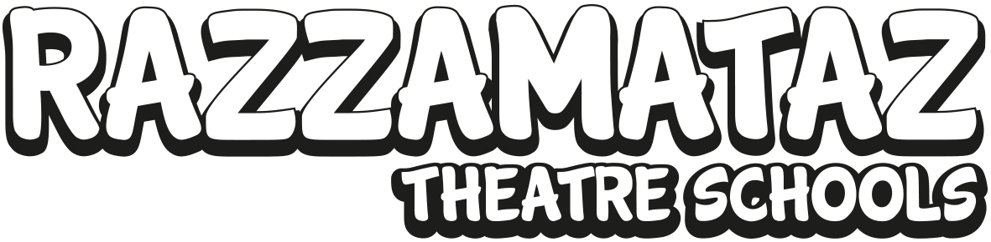

**Commit to help your child get fit and have fun in 2017**

The New Year is always when the gyms are at their fullest, people make promises to live a healthier lifestyle and more fruits and vegetables are consumed. Unfortunately, by February many people break these resolutions and slip back into bad habits.

It has been proven that to make healthy choices, it is important to make it into a part of everyday life and that is exactly the same for children. By enrolling them in a performing arts class, they are committing to turn up each week and participate in a class that is good for both mind and body. When considering exercise and children, the important part is to make fitness fun, or they will be turned off it for life before they’ve not had the opportunity to develop healthy habits.

Razzamataz Theatre Schools have an ethos where performing arts is about creating fit and active children while they are learning about the world and having fun. Participation in dance, drama and singing classes enable students to focus on different skills than they learn in school and offer an outlet for those with a passion for creativity and performance.

“Leading a fit and healthy lifestyle is not just about the foods we eat and the exercise we take,” says Denise Hutton-Gosney, MD and Founder of Razzamataz. “It is equally about creating well rounded, confident children who are able to empathize with others and put their feelings first. All these emotions and life lessons can be played out throughout performing arts classes and by doing so, we can help to create happy and healthy children who will reach their full potential.”

Razzamataz Theatre Schools offers classes in drama, dance and singing for children aged 2 to 18. As well as offering a diverse curriculum covering both the worlds of classic West End musical theatre and commercial pop and street dance, an important part of the classes is preparing for performing opportunities so all children have the chance to step into the limelight.

A key message for the theatre school and one that has been incorporated into all marketing materials is for students to ‘Create your best role.’ The message and meaning behind this is to show that no matter what your role is in life, be the best that you can be. This is true for performers but equally just as relevant for everyone from nurses, to lawyers to builders.

“Being your best self is about being the healthiest in both mind and body that you can be,” adds Denise. “Children naturally have lots of energy and it is important that we harness this and their creativity to steer them in a positive direction in life.”

There are almost 50 Razzamataz schools through the network and throughout the beginning of 2017, they are offering free trial classes to kick start a healthy 2017.

Razzamataz Theatre School launched in 2000 and started franchising in 2006 so this year they have been celebrating eleven years of being a successful franchise business with a saving worth £6,000. For the first three months of 2017, the franchise fee is just £7,995. Razzamataz will pay the first month management fee as well as the VAT equating to a saving of almost £6,000. T&Cs apply.

Since appearing on BBC’s *Dragons’ Den* and winning an investment from Duncan Bannatyne, Denise has grown the franchise business to almost 50 schools up and down the country. There have been hugely successful partnerships with the likes of First Choice, Her Majesty’s Theatre, *The Stage* newspaper, Barbie and Universal Pictures.

2017 is set to be another exciting year with partnerships with Disneyland Paris and Eurocamp already in place. Razzamataz and Eurocamp are currently working on an exciting competition with more details to be announced shortly.

Razzamataz is actively looking to open further schools across the UK and in particular Aberdeen and Cardiff, where the team will be holding Discovery Den days, which give people the opportunity to meet the Head Office team and find out more about this franchise opportunity. For those interested in buying a profitable existing business, there are currently opportunities in Tonbridge and Bristol.

If you want to find out more about becoming a franchisee of your own part-time Razzamataz Theatre School, make an appointment to come along to one of the regular but informal Discovery Den days in London, Glasgow or Sheffield to find out more about this exciting and flexible business opportunity. To book a place contact Head of Franchisee Recruitment Suzie McCafferty on [suzie@razzamataz.co.uk](mailto:suzie@razzamataz.co.uk) or call Suzie on 07793 054 233. For more details visit: [www.razzamataztheatreschools.co.uk](http://www.razzamataztheatreschools.co.uk).

**About Razzamataz**

Razzamataz Theatre Schools has been trading since 2000 with a strong, robust and proven franchise system for the last 11 years. Razzamataz remains one of the top five classic entrepreneurs from *Dragons’ Den*. Since the appearance on the BBC show in 2007, the company has forged strong partnerships with First Choice, Disney, The Stage, a leading Talent Agency, Her Majesty’s Theatre and new for 2017 Eurocamp.

Franchisees come from a range of backgrounds and are able to work flexibly around their lifestyles. Through a wide range of additional revenue streams, franchisees have been able to achieve a six-figure turnover. Razzamataz is delighted to be working with a new Business Management System for 2017.

**ENDS**

Pic 1

Razzamataz students in action

Pic 2

Opportunities to join the network in 2017 with huge financial incentives available